**Angela OVIEDO SABOGAL**

**REPORT ON NANOPHYTOPLANKTON ABUNDANCES AND CELLULAR VOLUME SAMPLE ANALYSIS (PERLE_0 AND PERLE_1)**

**Nanophytoplankton abundance calculation**

Samples were received in dry membrane filters, generally in good state except for P0_011_12 (A) and P0_002_06 whose filter surface was cover with overlying material, obstructing cells observation. For P0_011_12 (A) analysis was not possible, while P0_002_06 was analyzed by counting a short transept were no overlying material was found.

Membrane filters were cleared (render transparent) using immersion oil. The filter was examined with a Leica DM100 microscope equipped with polarization, phase contrast and brightfield optics. Transepts between 4.8 mm and 14.6 mm were observed under all optics. Birefringent coccolithophore cells and coccoliths were enumerated using cross polarized optics while non-birefringent cells were counted using phase contrast or brightfield optics. The filters were observed at a magnification of 1000X and 400X. Samples observed at the highest magnification were those were a smaller volume of water was analyzed and were the Detection limit of the method was highest, but also those with highest cells abundance (see Table 1). Given the magnification, volume filtered, and transept length examined, the effective volume counted per sample ranged between 2.2 - 33.0 ml (average 13.7 ml). A minimum of 100 cells were counted per sample (average of 190 cells and maximum of 777 cells).

Table 1.

|  |  |  |  |  |
| --- | --- | --- | --- | --- |
|  | Magnification | | | |
|  | 1000X | | 400X | |
| Av. Volume analysed, ml (Min., Max.) | 5.6 | (2.2 - 11.0) | 20.0 | (11.5 - 33.0) |
| Av. Counted Cells (Min., Max.) | 250 | (112 - 777) | 144 | (100 - 279) |
| Av.Total Cell Abundance, cells/l (Min., Max.) | 5.8E+04 | (1.5E+04 - 1.5E+05) | 8.0E+03 | (3.4E+03 - 1.4E+04) |
| Detection limit*, cells/l |  | (1.5E+03 - 3.0E+02) |  | (3.0E+02 - 1.0E+02) |
|  | Only PERLE_1 samples | | Mostly PERLE_0 samples | |

* Estimated from a Poisson distribution. It depends on the volume analysed, here for minimum and maximum volumes following Bollmann et al. (2002).

Coccolithophores (all sizes), and nanoplanktonic (<20 mm) organisms: diatoms, dinoflagellates, radiolarians, silicoflagellates, other flagellates and unidentified cells were counted. The identification of coccolithophore species / genus and their liths was done according to Frada et al. (2010) and the webpage www.mikrotax.org/Nannotax3/index.html where all taxa with full citations are presented. Large part of the diatoms, dinoflagellaes and other flagellates were left unidentified, although their shapes described. In some cases the genera were identified following Hasle et Syvertsen (1997) and Paulmier (1997) Paulmier (1997) [diatoms]. Please note that for most of the coccolithophore taxa not identified until species, a better taxonomic resolution can be achieve by checking the samples by SEM. Similarly, cases where two taxa are proposed for the same “class” could be discern using this technique. This is for example the case of the calss “Minidiscus sp. indet. or diatom resting spore indet.”, abundant in some samples.

Abundances of each taxa (cells/l), were calculated according to:

A=N*S/V

where A is the absolute abundance of the species; N is the number of cells of a species on the scanned piece of filter; S, the scaling factor (area of the whole filter/area of scanned filter piece) and V, the volume of the water filtered (litre).

Additionally, aggregates and birefringent particles not attached to cells (i.e. coccoliths, ascidian spicules, unidentified birefringent particles [in two size classes]) were also counted. Loose coccoliths and unidentified birefringent particles were counted from either a full field of view (FOV) or a half FOV, all along the transept examined. A minimum of 742 and maximum of 11258 birefringent particles (unidentified + ascidian spicules + coccoliths) were counted. Within aggregates only coccospheres or intact cells, when visible, were counted, coccoliths and other small material were not counted (example in Image 1)

Image 1. Example of counted aggregates, this one contains several coccoliths (not counted) and an ascidian spicule is lying next to (counted). When ever entire coccospheres where observed inside the aggregates (not in this example) they were counted.

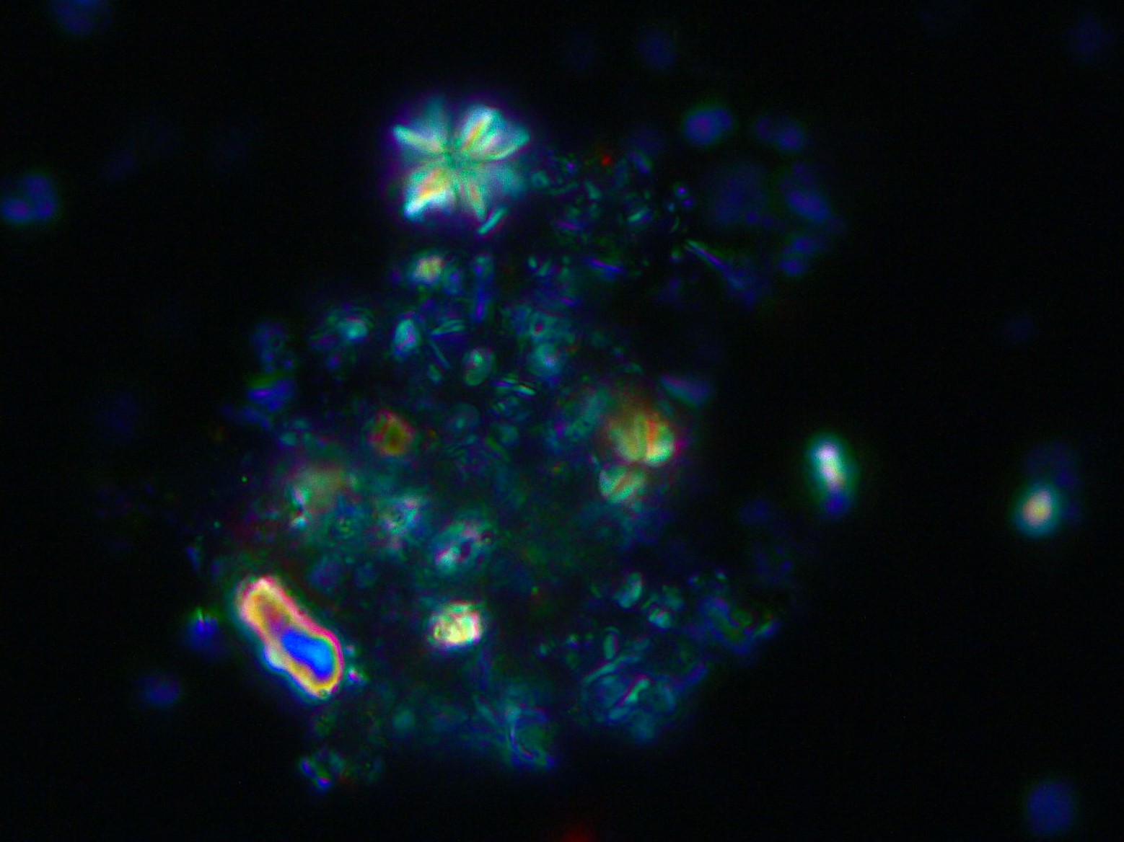

**Calculation of cellular volumes and organic carbon per cell**

A part of the recorded cells, detached coccoliths, aggregates, etc. were imaged using an ICC50W camera. The camera resolution was set to 2592 × 1944 (5MP). Measurements of cell dimensions were done by comparison of these images with those of a stage micrometer (S8). This technique yields results that are accurate to < 1.0 µm.

In order to calculate cell biovolumes (units: µm3), each imaged cell was assigned an idealised shape (e.g. sphere, prolate spheroid, cone, cylinder, etc) based on the work of Hillebrand et al. (1999); Sun (2003) and the HELCOM (Baltic Marine Environment Protection Commission – Helsinki Commission) Biovolume file 2018. In this regard HELCOM recommendations were also consulted trough the webpage [www.nordicmicroalgae.com](http://www.nordicmicroalgae.com).

Cell dimensions for each taxonomic group (e.g. diameter, length, width, height) were manually measured using the software Fiji - ImageJ (Schindelin et al. 2012) after setting the pixel -µm relation from stage micrometer pictures. Unless specified, cellular dimensions for coccolithophores include the coccoliths (coccosphere). For other groups, recorded dimensions are representative of the cell. All measurements used for volume calculations exclude appendices.

Cytoplasm dimensions have been published for very few coccolithophore species. Observations of 16 species of coccolithophore show cytoplasm diameter varying from 30 to 90 % of the total coccosphere diameter, depending on the species and level of calciﬁcation (O’Brien et al. 2013). The authors choose the midpoint and estimate coccolithophore biovolumes by assuming cytoplasm dimensions to be 60 % of the mean coccosphere dimensions. Here, I used 60 % for all species except for *Emiliania huxleyi*, often the dominant species in the analysed samples. For this species it is sometimes possible to distinguish coccosphere from internal content (i.e. cytoplasm) using images taken using polarized or phase contrast optics. I measured coccosphere and cell dimeters from 90 individuals and estimated a cellular volume that is between 17 and 62 % of the total coccosphere volume, with an average of 31 %. (Cytoplasm data in excel sheet “Volume”, columns “d2” and “Ehux cell_Calculated volume µm3”. Therefore, for *E. huxleyi* this percentage was used.

For nanoplanktonic diatoms, in most cases one of the cellular dimensions was not visible in the recorded images. The hidden dimension was then estimated from other measurements of the same genus in these set of samples or from available data for the genus/species in the HELCOM Biovolume file. For the class “Unidentified diatom (pennales)”, h was assumed to be 90 percent of w, as calculated from 82 measurements of pennate diatoms with parallelepiped shape available in the HELCOM Biovolume file. For the class “Unidentified diatom (centric)” h assumed to be 40 percent of d1 (as calculated from the HELCOM Biovolume file 2018 for Thalassiosira species and small unidentified centric diatoms, n=84). Details are reported in the “Volume” excel sheet, column “Notes”.

Cellular volume estimates were then further converted to carbon per cell (pg/c per cell) , according to conclusions of Menden-Deuer et Lessard (2000), who proposed a common protist conversion and another specific for diatoms. This is also the approach followed by the HELCOM, but could be changed by specific conversions (publish in the same work). Also note, that cyst, such as *Chaetoceros* cyst found in the analysed samples can have a higher cellular carbon content and other conversions could be used.

|  |
| --- |
| Diatoms: pgC cell-1=0.288 × volume0.811 |
| All other groups (Protists): pgC cell-1=0.216 × volume0.939 |

**References:**

Bollmann, Jörg, Mara Y. Cortés, Ali T. Haidar, Bernhard Brabec, Anne Close, Robert Hofmann, Sofia Palma, Luis Tupas, et Hans R. Thierstein. 2002. « Techniques for Quantitative Analyses of Calcareous Marine Phytoplankton ». *Marine Micropaleontology* 44 (3‑4): 163‑85. https://doi.org/10.1016/S0377-8398(01)00040-8.

Frada, Miguel, Jeremy Young, Mário Cachão, Sílvia Lino, Ana Martins, Áurea Narciso, Ian Probert, et Colomban de Vargas. 2010. « A guide to extant coccolithophores (Calcihaptophycidae, Haptophyta) using light microscopy ». *J. Nannoplankt. Res* 31: 58–112.

Hasle, Grethe R., et Erik E. Syvertsen. 1997. « Chapter 2 - Marine Diatoms ». In *Identifying Marine Phytoplankton*, édité par Carmelo R. Tomas, 5‑385. San Diego: Academic Press. https://doi.org/10.1016/B978-012693018-4/50004-5.

Hillebrand, Helmut, Claus-Dieter Dürselen, David Kirschtel, Utsa Pollingher, et Tamar Zohary. 1999. « BIOVOLUME CALCULATION FOR PELAGIC AND BENTHIC MICROALGAE ». *Journal of Phycology* 35 (2): 403‑24. https://doi.org/10.1046/j.1529-8817.1999.3520403.x.

Menden-Deuer, Susanne, et Evelyn J. Lessard. 2000. « Carbon to Volume Relationships for Dinoflagellates, Diatoms, and Other Protist Plankton ». *Limnology and Oceanography* 45 (3): 569‑79. https://doi.org/10.4319/lo.2000.45.3.0569.

O’Brien, C J, J A Peloquin, M Vogt, M Heinle, N Gruber, P Ajani, H Andruleit, et al. 2013. « Global Marine Plankton Functional Type Biomass Geography Distributions: Coccolithophores », 19.

Paulmier (Gérald). 1997. « Atlas des diatomophycées des côtes françaises et des aires océaniques adjacentes ». IFREMER.

Schindelin, Johannes, Ignacio Arganda-Carreras, Erwin Frise, Verena Kaynig, Mark Longair, Tobias Pietzsch, Stephan Preibisch, et al. 2012. « Fiji: An Open-Source Platform for Biological-Image Analysis ». *Nature Methods* 9 (7): 676‑82. https://doi.org/10.1038/nmeth.2019.

Sun, J. 2003. « Geometric Models for Calculating Cell Biovolume and Surface Area for Phytoplankton ». *Journal of Plankton Research* 25 (11): 1331‑46. https://doi.org/10.1093/plankt/fbg096.

HELCOM PEG Biovolume 2018 can be found at: <https://helcom.fi/post_type_project/peg/>